IoT Smart Fire Alert – System/ Software Requirements Specification (SRS)

Table of Contents

1. Purpose 3

1.1 Intended Audience 3

1.2 Intended Use 3

1.3 Scope 3

1.4 Definitions and Acronyms 4

2. Overall System Description 5

2.1 Use Case Diagram 5

2.2 System Architecture 5

2.3 Functional Requirements 6

2.3.1 Main Menu and Configuration 6

2.3.2 Automatic Fire Detection 8

2.3.3 Manual SOS Switch 11

2.3.4 Fire Alarm Deactivation Key 11

2.3.5 Alarm 12

2.3.6 SCDF Notification System 13

2.3.7 Sprinkler System 14

3. Software Architecture 15

# Purpose

## 1.1 Intended Audience

This SRS document outlines the System Requirements and Software Design for a Smart Fire Alert System. The primary users are the elderly living independently in homes or rental apartments in Singapore. Designed for elderly people who may have limited mobility or other health considerations that require clear fire alerts.

## 1.2 Intended Use

This SRS document describes the overall System Architecture, Functional Requirements and Software Architecture and Design. The intended use of the system is to continuously monitor and inform the elderly of a fire in their homes with an effective alarm system and alert the local fire department about the fire.

## 1.3 Scope

Input

1. Automatic Fire Detection System
   * Continuous monitoring of temperature and light intensity using sensors to identify a fire breakout.
2. Manual SOS Switch
   * In the event of an emergency where residents need to alert SCDF for urgent help required, this switch can be used.
3. Fire Alarm Deactivation System
   * This will only allow authorized personnel to turn off the fire alarm should there be a false activation of the fire alarm.

Output

1. Alarm System
   * Alarm to alert the residents living in the area to evacuate to safety.
2. Notification System
   * Automated notification system to request help from SCDF with clear instructions.
3. Sprinkler System
   * To pump water to the sprinklers to suppress the fire and minimize any further fire spread.

## 1.4 Definitions and Acronyms

|  |  |
| --- | --- |
| **Acronym/Abbreviation** | **Definition** |
| IR | Infra-Red |
| LED | Light Emitting Diode |
| LCD | Liquid Crystal Display |
| SCDF | Singapore Civil Defense Force |
| SW | Software |
| HW | Hardware |
| SMS | Short Message Service |
| Config | Configure/Configuration |
| 2 SF | 2 Significant Figures |
| SOS | “Urgent Help Needed” |
| GPIO | General Purpose Input/Output |
| HMI | Human-Machine Interface |

# 2. Overall System Description

## 2.1 Use Case Diagram

## 2.2 System Architecture

|  |
| --- |
| Raspberry Pi Development Board  LCD  Buzzer  LED  Servo Motor  Keypad  RFID Reader  Slide Switch  Temperature & Humidity Sensor (DHT11)  Light-Dependent Resistor (LDR)  **SPI_ADC GPIO23    GPIO17 GPIO24     GPIO27 GPIO25**  **SPI I2C     GPIO** |

## 2.3 Functional Requirements

### 2.3.1 Main Menu and Configuration

|  |  |
| --- | --- |
| **REQ_ID** | **REQUIREMENTS** |
| REQ-01 | When the System turns on, the following active detection menu will be displayed. Format temperature and light intensity to 2 SF. Constantly update the LCD to display the latest temperature and light intensity values. When scanning, LCD will display:  Line 1 = “Now scanning.”  Line 2 = “Temp:xx Light:xx” |
| REQ-02 | While in the main menu defined in REQ-01, if key # is entered in the keypad, enter the sensitivity adjustment menu below:  If key * is entered in the keypad, terminate the sensitivity adjustment and return to main menu  xx represents the old temperature threshold and yy should constantly update to display the currently read temperature value from sensor. Display the following lines in LCD and store collected data:  Line 1 = “Old Temp: xx”  Line 2 = “New thrshld: yy” |
| REQ-03 | While in the adjustment menu defined in REQ-02, if key # is entered in the keypad, enter the sensitivity adjustment menu below:  If key * is entered in the keypad, terminate the sensitivity adjustment and return to main menu   xx represents the old light threshold and yy should constantly update to display the currently read light value from sensor. Display the following lines in LCD and store collected data:  Line 1 = “Old Light: xx”  Line 2 = “New thrshld: yy”  After entering # in the keypad, return to main menu in REQ-01. |

### 2.3.2 Automatic Fire Detection

|  |  |
| --- | --- |
| **REQ_ID** | **REQUIREMENTS** |
| REQ-04 | Constantly ping sensors to collect data on the temperature and light intensity in the surroundings. Store the last 5 recorded data (of temperature and light intensity) in an array. |
| REQ-05 | Take and store the mean value of the last 5 recorded data in REQ-04. This mean value will be used to compare with threshold values to detect abnormally high temperature/light intensity. |
| REQ-06 | Every 10s: IF mean detected temperature > fire detection threshold temperature OR mean detected light intensity > fire detection threshold light intensity,  update the bool fireDetected to True. LCD will override main menu and display:  Line 1 = “Fire Detected”  Line 2 = “Alerted SCDF” |
| REQ-07 | Locate and store data on the location of the sensor that sensed the fire. |
| REQ-08 | Otherwise, if the fire detection conditions in REQ-06 are false,  LCD will momentarily override main menu and display:  Line 1 = “No Fire Detected”  Line 2 = “Temp:xx Light:xx” |

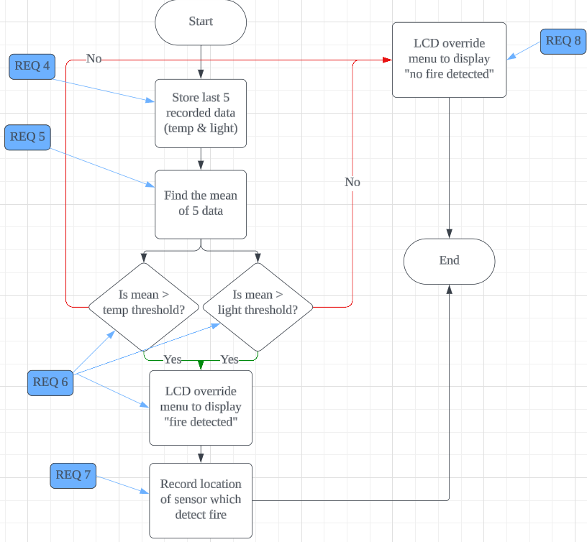

### 2.3.3 Manual SOS Switch

|  |  |
| --- | --- |
| **REQ_ID** | **REQUIREMENTS** |
| REQ-09 | When the manual SOS switch (slide switch) is switched to ON for 3s, then update the bool helpNeeded to True. Which immediately alert for help |

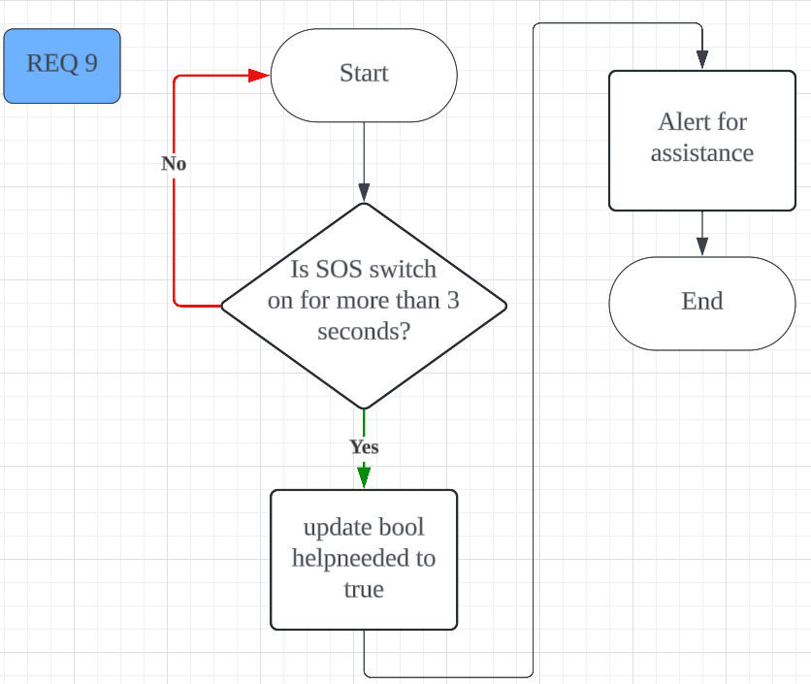

### 2.3.4 Fire Alarm Deactivation Key

|  |  |
| --- | --- |
| **REQ_ID** | **REQUIREMENTS** |
| REQ-10 | In the case of a false alarm, when the RFID tag triggers the RFID sensor, it will update the bool fireDetected to False. Deactivating the fire alarm |

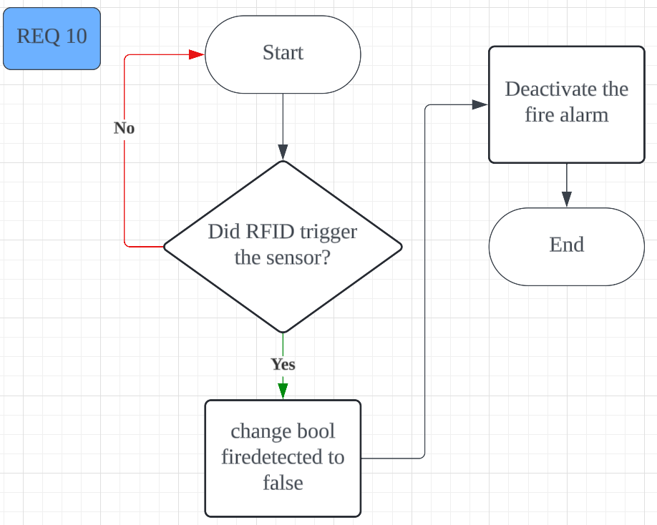

### 2.3.5 Alarm

|  |  |
| --- | --- |
| **REQ_ID** | **REQUIREMENTS** |
| REQ-11 | When the fire is detected (fireDetected = True), buzzer will constantly play a loud sound ON and OFF at 0.5Hz until fire alarm is turned off. |
| REQ-12 | When the fire is detected (fireDetected = True), LED must blink OFF and ON at 0.5Hz constantly until fire alarm is turned off. |

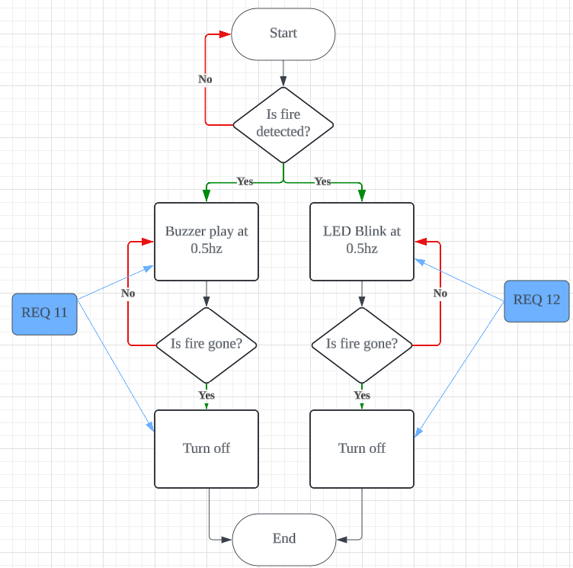

### 2.3.6 SCDF Notification System

|  |  |
| --- | --- |
| **REQ_ID** | **REQUIREMENTS** |
| REQ-13 | When the fire is detected (fireDetected = True) OR manual SOS switch is activated (helpNeeded = True), send an automated SMS/email alert to SCDF. |
| REQ-14 | The notification must specify if the situation is a fire or elderly needing urgent help. |
| REQ-15 | The notification system must include the location of the fire/activated switch within the house to assist first responders |

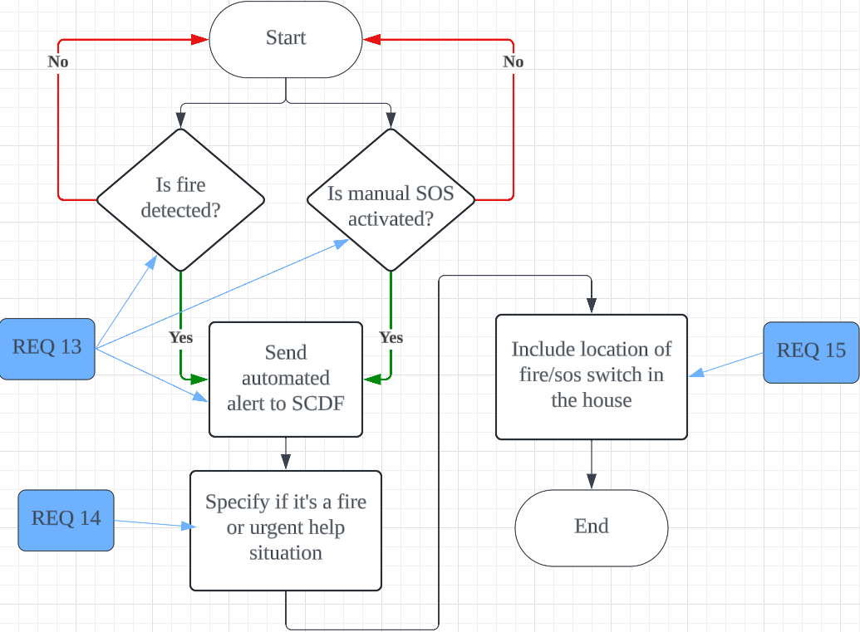

### 2.3.7 Sprinkler System

|  |  |
| --- | --- |
| **REQ_ID** | **REQUIREMENTS** |
| REQ-16 | When a fire is detected (fireDetected = True), activate the servo motor connected to the control valve. The servo motor should constantly pump water until fire alarm is turned off. |
| REQ-17 | The servo motor connected to control valve should be the nearest one to the fire (as found in REQ-07). |

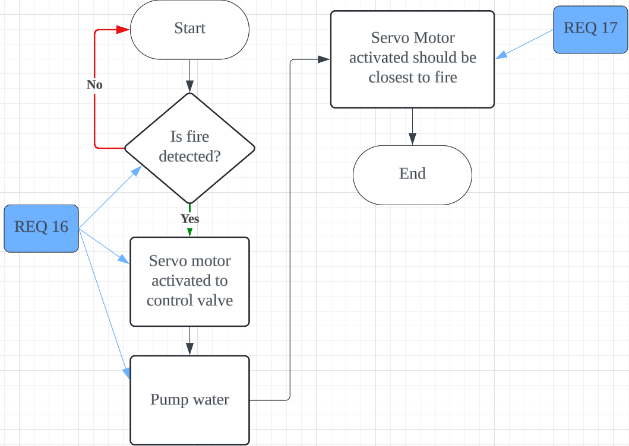

# 3. Software Architecture

Application Layer (AL)

Notification.py

Sprinkler.py

Alarm.py

SOS_Switch.py

Hmi.py

Detection.py

SOS_Switch.py

Deactivation.py

Alarm.py

Hardware Abstraction Layer (HAL)

input_switch.py

hal_temp_humidity_  
sensor.py

hal_buzzer.py

hal_adc.py

hal_servo.py

dht11.py

hal_keypad.py

hal_led.py

hal_lcd.py

hal_rfid_reader.py

|  |  |
| --- | --- |
| **No.** | **Peripherals Used** |
| 1 | LED |
| 2 | Buzzer |
| 3 | LCD |
| 4 | Keypad |
| 5 | RFID |
| 6 | LDR |
| 7 | Servo Motor |
| 8 | Temperature and Humidity Sensor |
| 9 | Slide Switch |